Reflection

Our reading this morning tell us ABOUT a remarkable event. John the Baptist tells the people who Jesus is. He is the LAMB of God who has been predicted a long time in their past to take away the sins of the world.

And then when John and his two disciples saw Jesus again the next day, John repeated his witness and said that Jesus is the lamb of God. John’s 2 disciples immediately followed Jesus. And then Jesus turned around and asked them a direct question namely What are you seeking?

They answered; Rabbi where are you staying? This is a weird answer for us. I am sure our modern GDPR laws will have a lot to say about this so-called infringement of privacy!

I wonder about Jesus’s question and their answer?

To understand their answer is to understand who they were and where they came from..

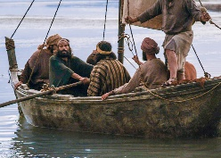
They were fishermen from the peasant class. The job of a fisherman in Jesus' day was difficult. Fishermen worked year-round in the heat of summer and the cold of winter, often at night. Certainly, Jesus' choice of Capernaum, on the Sea of Galilee, as his home brought him into contact with many fishermen. Several of his disciples - Andrew, Peter, James, and John - knew the trade well. It's possible that Jesus selected fishermen as his disciples not only because the imagery of their occupation fit well with the mission that he had called them to, but also because they were a hardy group of people, accustomed to difficult work and long hours. Jesus even asked them to return to the lake and fish again after a night of fishing without a catch (Luke 5:1-7).

Interestly in the other Gospels Jesus calls His disciples .. in our reading they simply spontaneously follow him…and confess that He is the anointed one, the Messiah which lead to Simon Peter following Jesus too..

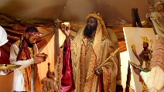
Jesus found His disciples not in fancy palaces but along the lake – ordinary working class men!

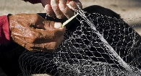
One of the most important skills of fishermen was making and mending nets. Made of linen, a common fabric used in the ancient Near East, these nets had to be carefully cleaned and dried each day or they would quickly rot and wear out. The majority of a fisherman's life probably was spent mending nets. Net weights, small pieces of stone with holes drilled in them, were fastened to the bottom of the nets. This too took time. Fishermen also had to be skilled, of course, in the use of the nets in fishing for various types of fish.

The disciples' task was to become "fishermen" for the kingdom. The long hours, the carefully practiced skills, and the various techniques and nets used in catching specific kinds of fish all must have passed through their minds. Seeking people to follow Jesus would take the same care, dedication, and skill used in fishing (Matt. 4:18-19). The disciples learned that they must seek all kinds of people to follow Jesus, though some would eventually turn away.


The fishing motif apparent in Jesus' teaching about the kingdom was so strong that the Greek word for fish (ichthus) came to represent Jesus' name. The first letters of the Greek words meaning "Jesus Christ, God's Son, Savior" spell ichthus. The fish itself appropriately became a symbol for Jesus.

As his disciples, we must learn the lessons he taught, becoming his new fishers of men and women and finding ways to bring all kinds of people to him. We are all the same and all of us need God in our lives. We need to follow Jesus too – spontaneously especially because we have the hindsight to know what He has done. And in our following becoming witnesses to bring other to HIM just like Andrew did. Because a lot of people are seeking Jesus … they need a Saviour!

It seems clear from our reading that John the Baptist and the other disciples applied the words “Come, see, tell, repeat”.

If there ever was someone in Scotland who emphasized that all people are the same in the eyes of God, it was Robert Burns. He himself came from a humble abode but realized the unfairness and unequalness of his society.

In one poem called “to a Louse” he is making the satirical comment that indeed we should see ourselves for who we are.

It is quite a funny poem of a not-so-funny topic which I am sure resonates with all of us.
Now, I do not have to tell you this, but even just thinking about head lice, my scalp begins to itch …
Robert Burns was making the point that a lice can climb on all people – the poor and the rich, the famous and the not so famous.
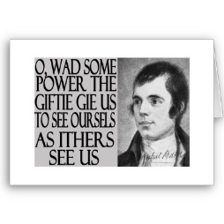

God looks at us with different eyes. He sees our hearts and judges us with eyes of love. He sent Jesus as the Lamb to take away our sins.

I cannot help but think that Robert Burns understood the biblical message of who we are. We are all indeed at the same time sinners and being redeemed.

We need to ask ourselves: what is our witness like? How do others see our following of Jesus Christ? What do they see?

Do they see God’s love in our actions?
Do they hear the hope of God in our voices?
Do they see the LIGHT of Christ in lives of faith?

May we practise that we are witnesses of Jesus Christ who needs to follow HIM with all that we have and breathe.

And in our following remember that we are all equal in the eyes of God. We are all important in God’s eyes.


Is it not remarkable that Robert Burn’s song “For auld lang syne” tradionally have people from all backgrounds holding hands and singing together…even the KING of England holding hands with the working class and singing:
“And there’s a hand my trusty friend!
And give me a hand o’ thine!”

Let us listen now to his song …..

