Sermon
5 September 2021
Balerno Parish Church

By: Rev Drs André & Jonanda Groenewald
Reading: Mark 8: 27-38

Reflecting on God’s Word

Reading: Mark 8:27-38

Peter declares that Jesus is the Messiah
²⁷ Jesus and his disciples went on to the villages around Caesarea Philippi. On the way he asked them, ‘Who do people say I am?’ ²⁸ They replied, ‘Some say John the Baptist; others say Elijah; and still others, one of the prophets.’ ²⁹ ‘But what about you?’ he asked. ‘Who do you say I am?’ Peter answered, ‘You are the Messiah.’
³⁰ Jesus warned them not to tell anyone about him.

Jesus predicts his death
³¹ He then began to teach them that the Son of Man must suffer many things and be rejected by the elders, the chief priests and the teachers of the law, and that he must be killed and after three days rise again. ³² He spoke plainly about this, and Peter took him aside and began to rebuke him.³³ But when Jesus turned and looked at his disciples, he rebuked Peter. ‘Get behind me, Satan!’ he said. ‘You do not have in mind the concerns of God, but merely human concerns.’

The way of the cross
³⁴ Then he called the crowd to him along with his disciples and said: ‘Whoever wants to be my disciple must deny themselves and take up their cross and follow me. ³⁵ For whoever wants to save their life^{[a]} will lose it, but whoever loses their life for me and for the gospel will save it. ³⁶ What good is it for someone to gain the whole world, yet forfeit their soul? ³⁷ Or what can anyone give in exchange for their soul? ³⁸ If anyone is ashamed of me and my words in this adulterous and sinful generation, the Son of Man will be ashamed of them when he comes in his Father’s glory with the holy angels.’

MP 536 On a hill far away stood an old rugged cross

On a hill far away stood an old rugged cross,
the emblem of suffering and shame;
and I love that old cross where the dearest and best
for a world of lost sinners was slain.

Refrain:
So I'll cherish the old rugged cross,
till my trophies at last I lay down;
I will cling to the old rugged cross,
and exchange it some day for a crown.

O that old rugged cross, so despised by the world,
has a wondrous attraction for me;
for the dear Lamb of God left his glory above
to bear it to dark Calvary. [Refrain]

In that old rugged cross, stained with blood so divine,
a wondrous beauty I see,
for 'twas on that old cross Jesus suffered and died,
to pardon and sanctify me. [Refrain]

To that old, rugged cross I will ever be true,
its shame and reproach gladly bear;
then he'll call me some day to my home far away,
where his glory forever I'll share. [Refrain]

Sermon

I hope you enjoy this cartoon….

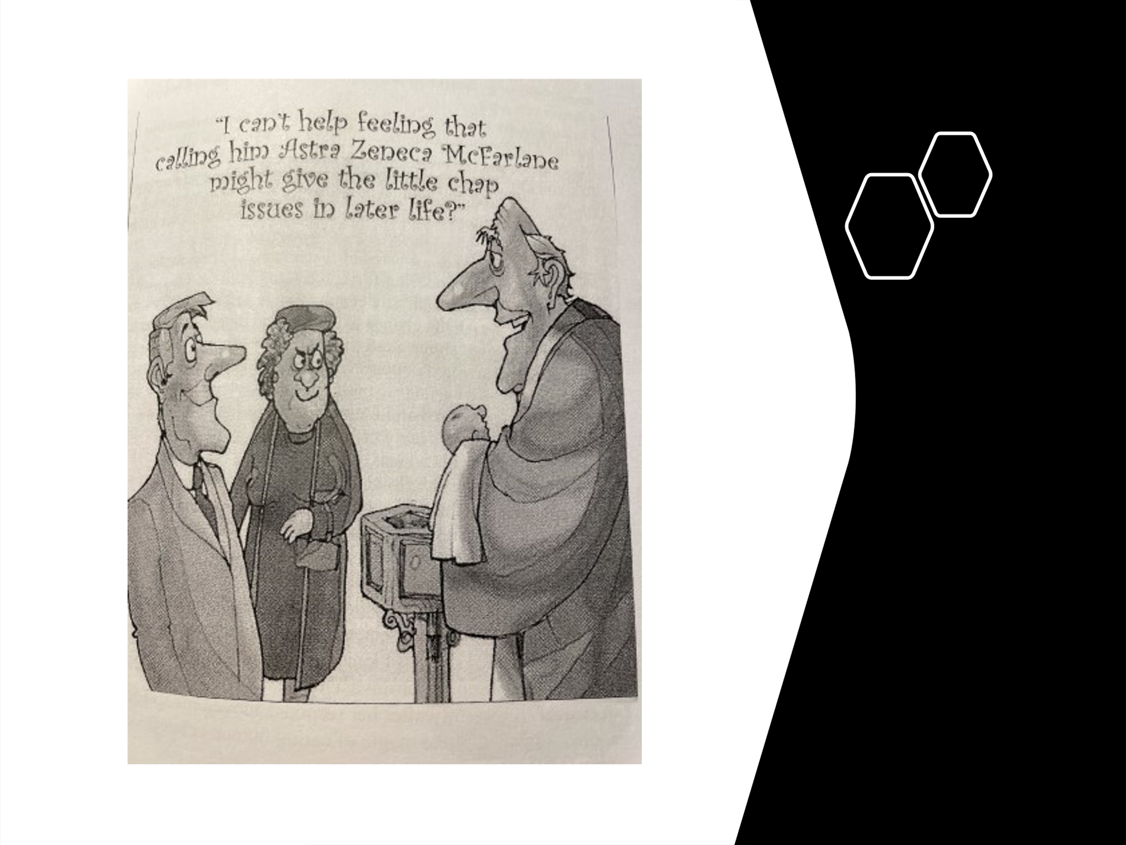
The wording is not too clear but for those of you who cannot read it: the minister says: I cant help feeling that calling him Astra Zeneca McFarlane might give the little chap issues in later life”

Although it is very funny it, the minister is making a good point. Often our names identify who we are and where we come from. In a sense our identities are determined by our first names.

In our Bible reading it is all about Jesus’ identity.



In the Gospel of Mark Jesus’ true identity is a top secret. The disciples did not have a clue who Jesus was, hence Jesus’ questions.


Jesus starts of by asking them who the people think He is….
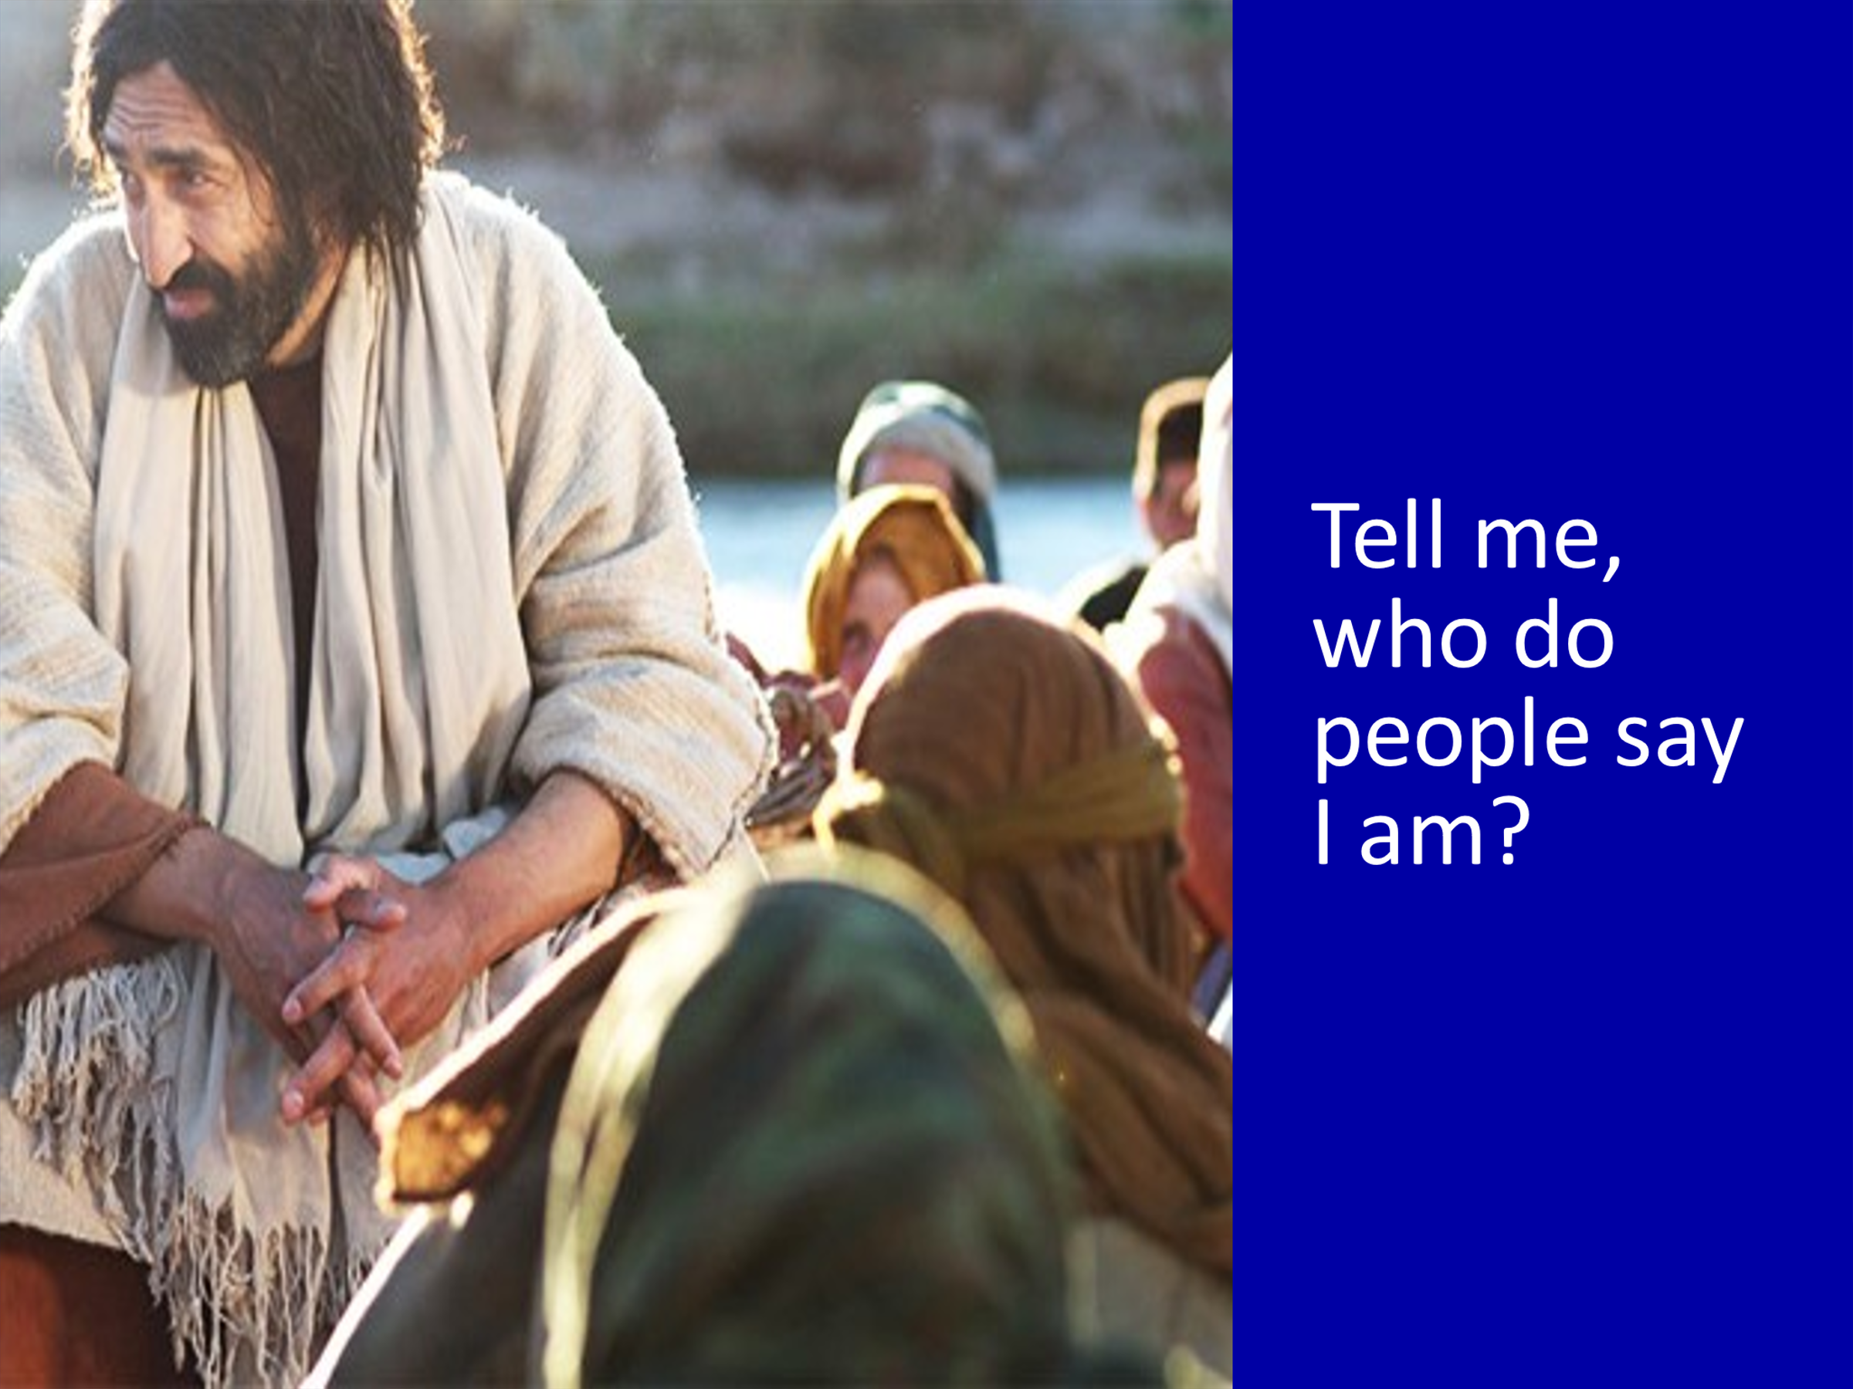

They answered Jesus by calling out random names… John the Baptist; others say Elijah; and still others, one of the prophets.. again each name is linked to a specific identity… with whom they associate Jesus.
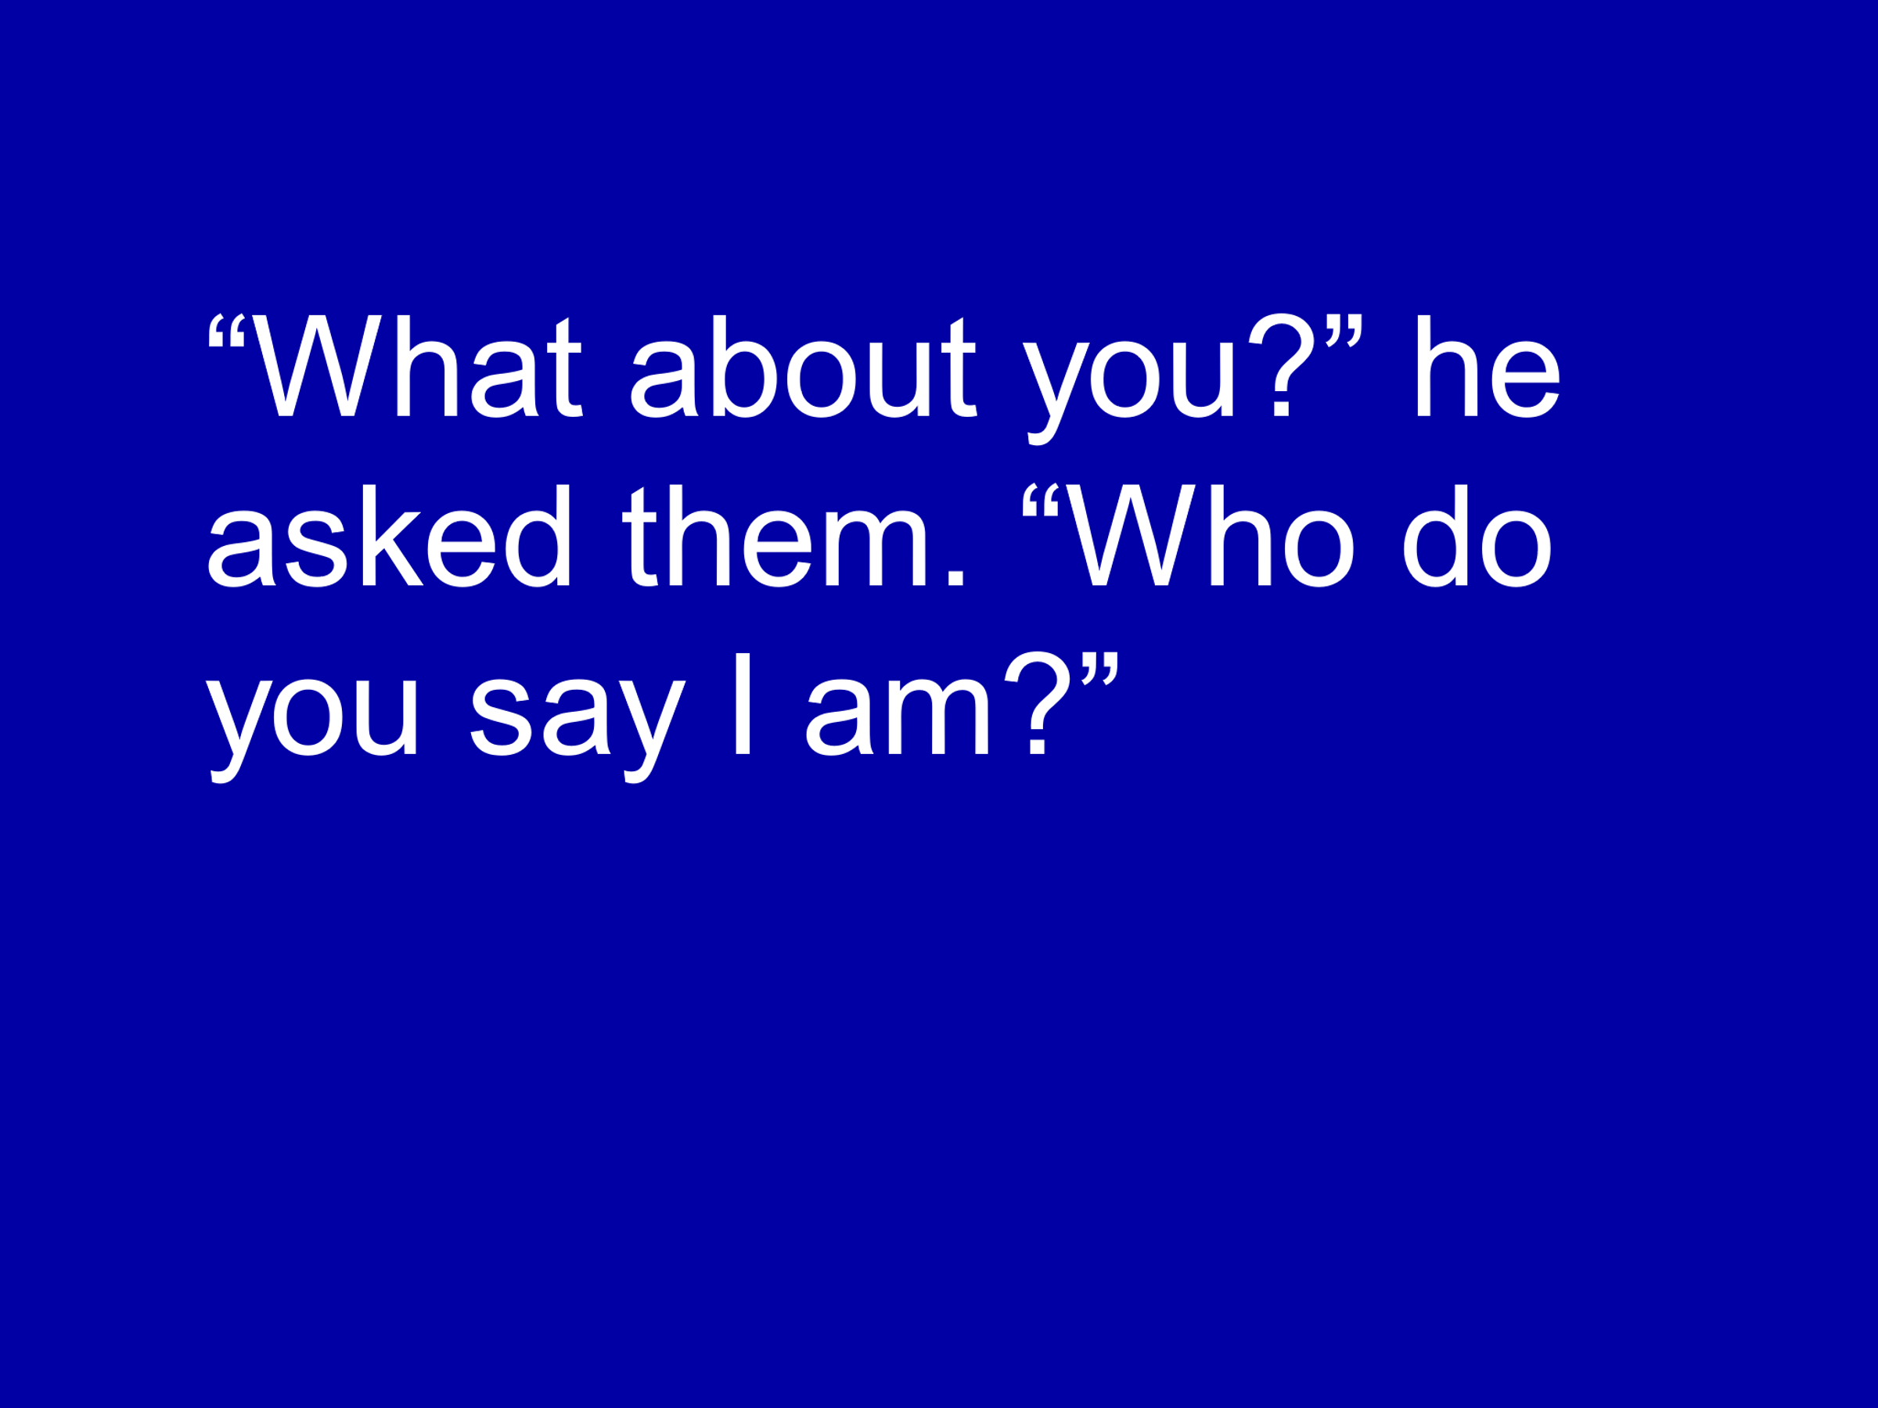
But then Jesus totally takes the wind out of their sails by directing the question at them: Who do you say I am? Interestingly Peter then responds first by saying: Jesus is the Messiah.

We all assume that he was right but that would only be half of it. The Messiah that was expected by all the Jews was someone who would get rid of the Roman rule and set up a “pure Jewish state”. The Messiah was a political figure who was not a leader but a follower of the people’s votes. Jesus on the other hand was not a political figure but the Redeemer of humanity.

This explains why Jesus had to explain in great lengths the real mission of the Messiah was not to be served but to serve by dying on the cross for the salvation of humanity. Jesus refers to Himself as the “Son of man” which was a loaded title coming from the Old Testament especially in Apocalyptic literature such as in the books of Daniel or Ezekiel.

In Mark 8:31 Jesus starts teaching his disciples (he continues in 9:30-31 and 10:32-33) that the Son of man must undergo great suffering, and be rejected by the elders, the chief priests, and the scribes, and be killed, and after three days rise again. A characteristic of these teaching is that Jesus refers to himself as the Son of man every time he warns his disciples about his coming persecution and death. The arrest and conviction would lead to his death, but after three days he will rise again, proving his subsequent vindication, hinting that Daniel 7 was a fitting metaphor for Jesus' crucifixion and subsequent resurrection, within the context of suffering and exaltation

In Mark 8:38 Jesus warns that those who are ashamed of him and his words will find that the Son of man is ashamed of them when he comes in the glory of his Father with the holy angels, alluding to Daniel 7:13-14. In an allusion to Daniel 7:13-14, Jesus assumes the identity of the One who is given dominion and glory and kingship that all peoples, nations and languages should serve him. Jesus identified with the Son in man figure in Daniel 7:1:. “He was given authority, glory and sovereign power; all nations and peoples of every language worshiped him. His dominion is an everlasting dominion that will not pass away, and his kingdom is one that will never be destroyed.”

After Jesus’ explanation it was evident that the disciples still did not grasp Jesus’ true Identity. Their understanding would only come after Jesus was resurrected.

Do we know better? Having the advantage of knowing about the resurrection and ascension of Jesus?

The same question remains relevant on this day as it did a long time ago namely: who do we say is Jesus? Or more directly who is He to you, and me?

There cannot be just one answer to this question. We are all different and all of us experience our journeys of faith differently. Some will identify with Jesus as the Son of Man who will come again in Glory and establish the Kingdom of God. Some will identify with Jesus’ quest to include all people, to draw in all that is standing on the margins of society. Some will identify with Jesus clear judgment of what is right and wrong, just and unjust. Others will identify with His shame, suffering and pain on the cross.

As believers, who Jesus is to us will be reflected in our everyday actions, words and thoughts. We carry the name of Christians which means that we identify as followers of Jesus.

So when ever and where ever we follow Jesus in Word and deed, when we sacrifice for our faith in and through Jesus Christ, we identify with Jesus in faith. Whenever we love in the same way as Jesus taught us which is symbolized by Holy Communion – we are modelling Jesus’ behaviour on earth.

Whenever we help the most vulnerable in our society, we are doing what Jesus did. When we help others – even at the expense of ourselves – we are following Jesus’ command. Whenever we forgive – we are truly His disciples.

You and I are followers of Jesus – we are brothers and sisters through faith alone. And today this is symbolized by sitting at the Table of God where He is the Host not just serving us bread but His very self so that we may be healed, restored and forgiven. Today once again we are reminded of HIS love for us and the responsibility that we have towards our brothers and sisters in faith.

But we also have a huge responsibility in our society to make a difference when and wherever we can. As followers of Jesus we have to model and act out what Jesus did a long time ago – to include all those who are suffering injustice, to love unconditionally, to forgive mercifully, and to pray to God wherever and whenever we can. No wonder the Guild’s motto is “Whose we are and whom we serve” clearly making the connection between our identity as Christian believers and God, whom we serve. May we never forget our identity as followers of Jesus, who died for us, was resurrected and ascended to heaven.
Amen

