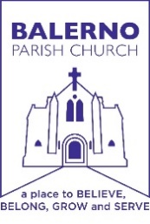
Order of Service
Balerno Parish Church
Balerno Linked with Currie
23rd Sunday after Pentecost
16th November 09:30am

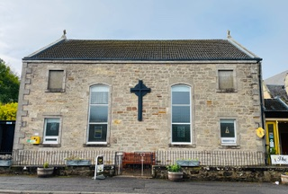

Worship led by Rev. Roy Henderson
Musicians Martin Petty and the choir

Edinburgh Balerno Parish Church of Scotland: Scottish Charity No 018012
Gathering of God’s People
Time when we greet one another and prepare for worship. Those who are able please stand for the entry of the Bible. Words of welcome and announcements.
Worshipping God Together
Call to Worship Minister: Do you see this the village of Balerno ? Here God dwells among the people. All: God will make a home among us and we shall be God’s people. Minister: God is the beginning and the end and is making all things new. All: Let us worship God together ! (Dorothy McRae-McMahon, adapted)

Hymn CH4 476 Mine eyes have seen the glory of the coming of the Lord
Prayer & Lord’s Prayer We ask this in the name of Jesus who taught us to pray: ALL: Our Father, who art in heaven, Hallowed be thy name. Thy kingdom come, Thy will be done on earth as it is in heaven. Give us this day our daily bread; And forgive us our debts as we forgive our debtors. And lead us not into temptation, but deliver us from evil. For Thine is the kingdom, the power, and the glory for ever. Amen.
Opening Thoughts

Hymn CH4 61 O sing a new song to the Lord
Reflecting on God’s Word
Reading 1: 2 Thessalonians 3: 6-13 read by George Burt

Choir sings SGP 56 Jesus stand among us - by Graham Kendrick
Reading 2: Luke 21:5-19 Bible reading read by George Burt

Hymn CH4 472 Come, thou long expected Jesus
Sermon

Dedication All: God of all goodness and grace, receive every gift we offer;
and grant that our whole life may give you glory and praise;
through Jesus Christ our Lord. Amen.

Responding to God’s Word
Prayer for others: Lesley Burt

Hymn CH4 465 Be thou my vision

Sending
Minister: The night shall be no more and we will need no light from lamps. All: For God is our light, and always walks before us. (Dorothy McRae-McMahon)

Blessing

Threefold Amen

Please remain standing as The Bible is removed

You are invited to stay for tea and coffee which are served in the hall.

THANKS TO YOU…Thank you for all your generous contributions towards the ministry and mission of the Church. Gift Aid envelopes are available in the wallets at the end of each row.
Sort code 83 - 19 - 15
Account 00119731
Balerno Church of Scotland

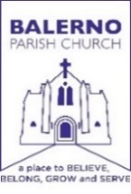 | BALERNO PARISH CHURCH  Intimations  Sunday, 16th November 2025
What’s on November/ December 2025
Church Services 23 November: Church services 09:30 Balerno & 11:15 Currie led by Rev. Roy Henderson Intimations Chat Room: Speak to Rev. Roy Henderson Wednesday in the Shepherd Room from 12:30-13:30 Recording of Services: Please note that services are recorded and uploaded to You-Tube for the benefit of those who are unable to attend church. If you do not wish to appear in the video then please avoid sitting in the front four rows of the congregation. Thank-you. 16 November: Church walk after the 11:15 service at Currie Kirk 18 November: Currie Guild at Gibson Craig Halls 14:00 Nature Closely Observed Speaker: George Anderson 19 November: Balerno Guild at Ogston Hall 19:30 Conservation enhancement & protection Speaker: Andrew Marsden from the Friends of Pentlands. 21 November: 11:00am WE NEED YOUR HELP AGAIN The poppies need to be lifted and the cascades taken down.It would be appreciated if you could take some home to dry off in vases then return them to the church the following week if possible. There will be carrier bags and buckets for your use. Any leftover will be at the church to take home after the service. (Balerno) 28 November: Messy Church 14:00-16:00 Gibson Craig Hall Currie 02 December: Currie Guild at Gibson Craig Halls 10:00 The Scottish Prison Service Speaker: Rev Sheena Orr 3 December : 3rd December: Balerno Guild at Ogston Hall 19:30 Christmas Flowers with Shelagh Anderson. 4 December: Lighting of Church Christmas Tree 18:00 with Pipe Band & Santa switching on lights at 18:15 Rotary Tree of Life is supporting the Doddy Weir Foundation (MND) 4 December: Switching on of Christmas Tree lights in mains Street Balerno 18:45 with Dean Park Primary School Choir & Balerno District Schools Pipe Band 6 December: Currie Kirk Christmas Fayre 13:00-16:00 Gibson Craig Hall 13 December: Broxburn & Livingston Brass Band Concert Balerno Church 19:30 Tickets £10 Under 16 £5 available from the Church office

